✔️ Writing Checklist
- ☐ Write a title (1)
- ☐ Use first / next / then / last correctly (4)
- ☐ Write 4 complete sentences (4)
- ☐ Use capital letters and periods (2)
Look at the pictures and write sentences using first, next, then, and last.
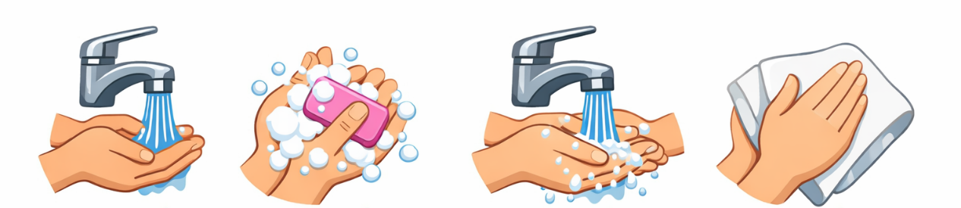
Mind Map (write 4 ideas):

Write your sentence

___________________________________________________________________________

___________________________________________________________________________

___________________________________________________________________________

___________________________________________________________________________
✔️ Writing Checklist
- ☐ Write a title (1)
- ☐ Use first / next / then / last correctly (4)
- ☐ Write 4 complete sentences (4)
- ☐ Use capital letters and periods (2)
Look at the pictures and write sentences using first, next, then, and last.

Mind Map (write 4 ideas):

Write your sentence

___________________________________________________________________________

___________________________________________________________________________

___________________________________________________________________________

___________________________________________________________________________
✔️ Writing Checklist
- ☐ Write a title (1)
- ☐ Use first / next / then / last correctly (4)
- ☐ Write 4 complete sentences (4)
- ☐ Use capital letters and periods (2)
Look at the pictures and write sentences using first, next, then, and last.
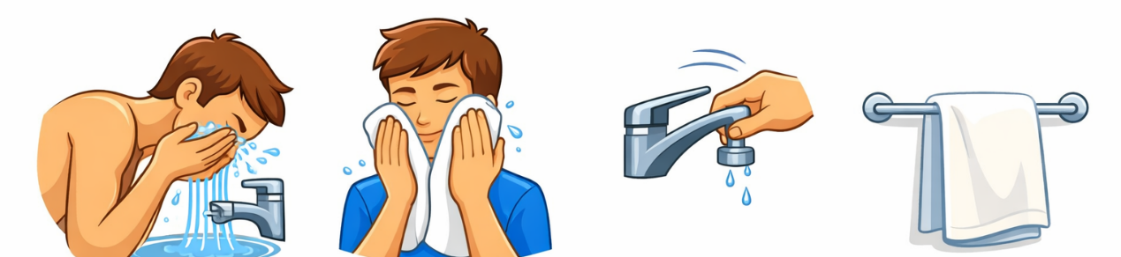
Mind Map (write 4 ideas):

Write your sentence

___________________________________________________________________________

___________________________________________________________________________

___________________________________________________________________________

___________________________________________________________________________
✔️ Writing Checklist
- ☐ Write a title (1)
- ☐ Use first / next / then / last correctly (4)
- ☐ Write 4 complete sentences (4)
- ☐ Use capital letters and periods (2)
Look at the pictures and write sentences using first, next, then, and last.

Mind Map (write 4 ideas):

Write your sentence

___________________________________________________________________________

___________________________________________________________________________

___________________________________________________________________________

___________________________________________________________________________
✔️ Writing Checklist
- ☐ Write a title (1)
- ☐ Use first / next / then / last correctly (4)
- ☐ Write 4 complete sentences (4)
- ☐ Use capital letters and periods (2)
Look at the pictures and write sentences using first, next, then, and last.
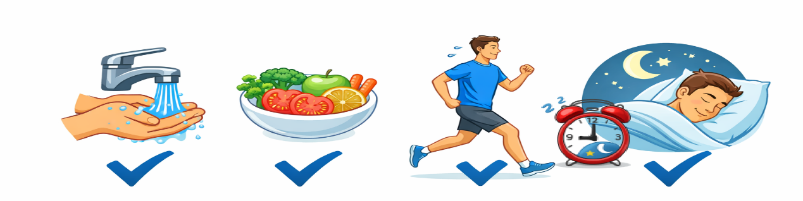
Mind Map (write 4 ideas):

Write your sentence

___________________________________________________________________________

___________________________________________________________________________

___________________________________________________________________________

___________________________________________________________________________

